**AACS1084**

# Programming Concepts & Design II

**Assignment**

**2024**

| Programme | : | Diploma in Information Technology |
| --- | --- | --- |
| Tutorial Group | : | Group 4 |
| Date Submitted to Tutor | : |  |

**Team Members:**

| **No** | **Student Name** | **Student ID** |
| --- | --- | --- |
| 1. | Chaw Chun Jia | 2302608 |
| 2. | Ooi Jun Kang | 2302732 |
| 3. | Goh Chun Wen | 2302211 |
| 4. | Wong Shun Bin | 2302292 |

| No. | Team Member | Task(s) Allocated | Overall Contribution (%) |
| --- | --- | --- | --- |
| 1. | Chaw Chun Jia | Train Scheduling Module | 25% |
| 2. | Ooi Jun Kang | Member Module | 25% |
| 3. | Goh Chun Wen | Ticket Booking Module | 25% |
| 4. | Wong Shun Bin | Staff Module | 25% |

**Coursework Declaration**

We confirm that we have read and shall comply with all the terms and conditions of TAR University College’s plagiarism policy. We declare that this assignment is free from all forms of plagiarism and for all intents and purposes is our own properly derived work.

| Signature | : | Chaw | Jkang | Chun | **Wong** |
| --- | --- | --- | --- | --- | --- |
| Name | : | Chaw Chun Jia | Ooi Jun Kang | Goh Chun Wen | Wong Shun Bin |
| Photo | : |  |  |  |  |
| Date | : | 2/5/2024 | 2/5/2024 | 2/5/2024 | 2/5/2024 |

### Assignment Evaluation Form

| **Student Name** | | Chaw Chun Jia | Ooi Jun Kang | Goh Chun Wen | Wong Shun Bin |  |
| --- | --- | --- | --- | --- | --- | --- |
| **Module handled** | | Train Scheduling | Member | Ticket Booking | Staff |  |
| ***Assessment Criteria*** | ***Marks Awarded*** | | | | | |
| ***Application of Programming Knowledge*** | |  | | | | |
| Structures   * Basic + extra fields, * Use of nesting & arrays * Appropriate usage | **12** |  |  |  |  |  |
| File Processing   * successful processing * Validation of data * Appropriate usage | **12** |  |  |  |  |  |
| Functions   * 4 Basic file fns, * Extra file fns, useful/correct * Approp. menu design & process | **12** |  |  |  |  |  |
| Others   * Use of parameters; correct usage * Subsidiary working functions * Minimized global variables | **12** |  |  |  |  |  |
| Teamwork   * Main menu, logo etc * System/module integration * Report integration/content * Sharing of files, functions * Communication, cooperation | **12** |  |  |  |  |  |
| Program originality, efficiency and readability   * Innovation, uniqueness * Approp. logic structures * Code Readability | **10** |  |  |  |  |  |
| Report (indiv. section)   * Clarity of description * Narrated Screens for all processes (basic + extra) | **20** |  |  |  |  |  |
| Penalty - Late Submission   * 1-3 days late 🡪 -10 * 4-7 days late 🡪 -20   >7 days late => **Total mark = 0** |  |  |  |  |  |  |
| **Subtotal (i)** |  |  |  |  |  |  |
| Presentation   * Organization, explanation * Enthusiasm, preparedness, attitude, understanding * Q&A handling **Subtotal (ii)** | **10** |  |  |  |  |  |
| **TOTAL MARK** |  |  |  |  |  |  |

Note: In addition to the late penalty, marks will also be deducted under the different categories for other reasons, eg. bad programming practices, uncooperativeness, etc.

### Table of Contents

| ***Chapter*** | ***Description*** | ***Page No*** |
| --- | --- | --- |
| 1 | Introduction | 1 |
| 2 | Overall System - Module Structure Chart | 2 |
| 3 | Main Screen Design | 3 |
| 4 | System Modules | 4-31 |
| 4.1 | Staff Management by Wong Shun Bin | 4-10 |
| 4.2 | Member Management by Ooi Jun Kang | 11-17 |
| 4.3 | Train Scheduling by Chaw Chun Jia | 18-24 |
| 4.4 | Ticket Booking by Goh Chun Wen | 25-31 |
| 5 | References | 32 |

### 

### 1.0 Introduction

The Train Booking Schedule System, meticulously crafted in C programming language, stands as a comprehensive solution tailored to efficiently manage key aspects of train booking operations. With a core focus on staff management, member registration, ticket booking, and train scheduling, this system aims to streamline processes, enhance user experiences, and optimize resource utilization.

Staff Management Module:

At the heart of the system lies the Staff Management Module, where administrators wield the tools to orchestrate the roles, accounts, and permissions of personnel. Through this module, the allocation of responsibilities is finely tuned, ensuring smooth collaboration among team members while maintaining robust security measures to safeguard sensitive information and system integrity.

Member Registration Module:

The Member Registration Module serves as the gateway for passengers to establish their presence within the system. Offering a seamless registration process, passengers can create and manage their accounts with ease, providing necessary personal details and preferences. Beyond mere registration, this module fosters a personalized experience, allowing users to track their booking history, set preferences, and participate in loyalty programs, thereby enhancing customer engagement and retention.

Ticket Booking Module:

Central to the passenger experience is the Ticket Booking Module, where the journey from inquiry to confirmation is seamlessly navigated. Passengers are empowered to explore available train options, select preferred routes, and secure their bookings with confidence. Through secure payment gateways and robust validation mechanisms, the module ensures the integrity and confidentiality of transactions, culminating in the issuance of electronic tickets that encapsulate vital itinerary information.

Train Scheduling Module:

The Train Scheduling Module serves as the backbone of operational efficiency, meticulously orchestrating the intricate dance of train routes, schedules, and capacities. Administrators wield a suite of tools to optimize resource allocation, fine-tune routes based on demand patterns, and adapt schedules to evolving operational needs. By harnessing the power of data-driven insights, this module empowers railway companies to maximize revenue, minimize resource wastage, and deliver superior service to passengers.

In essence, the Train Booking Schedule System represents a culmination of innovation, efficiency, and user-centric design, poised to redefine the landscape of train booking management. Through its unwavering commitment to excellence, the system streamlines operations and elevates the overall passenger experience, ushering in a new era of efficiency and convenience in railway travel

### 2.0 Overall System – Module Structure Chart

### 

### 3.0 Home Screen / Splash Screen

### 

### 4.0 System Modules

#### 4.1 Staff Management by Wong Shun Bin

##### 4.1.1 Description

The Staff Information Module serves as the backbone for managing all staff-related activities within the train ticketing system. It allows the system administrator or authorized personnel to add, view, modify, and search staff information, search for specific staff and backup staff details. This module ensures the security and integrity of staff data by providing functionalities to create and maintain staff login accounts and their associated details.

##### 4.1.2 Outputs & File Contents

###### **Module's Main Page:**

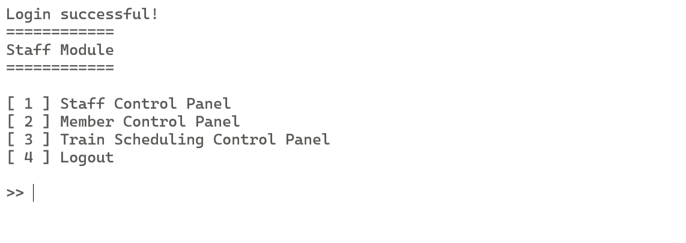

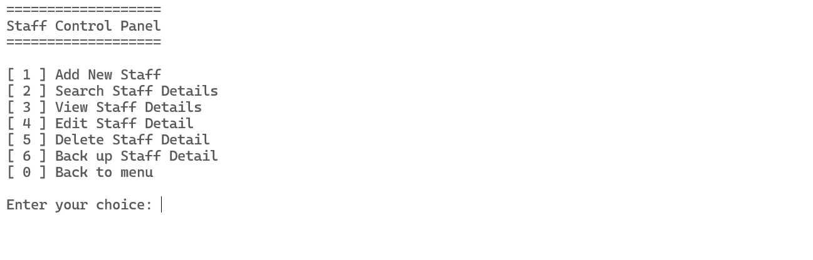

###### File's Existing Data: The user selects "Display Staff" to view existing staff records.

###### 

###### 

###### **Adding a Record:** The user selects "Add Staff" and enters the details of the new staff member.

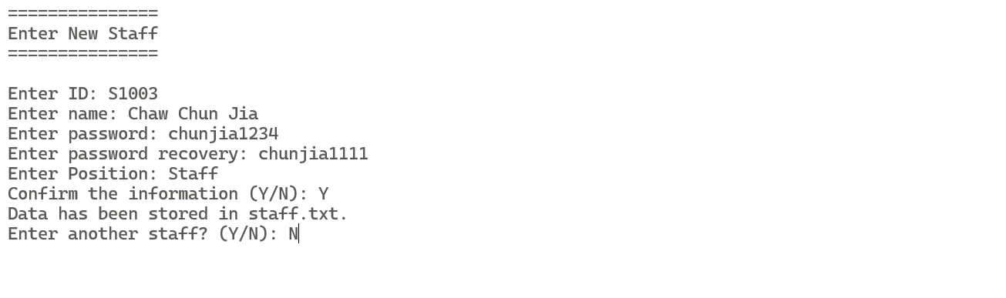

###### 

###### Modify a Record: The user selects “Modify Staff” and edit the field they wanted to edit.

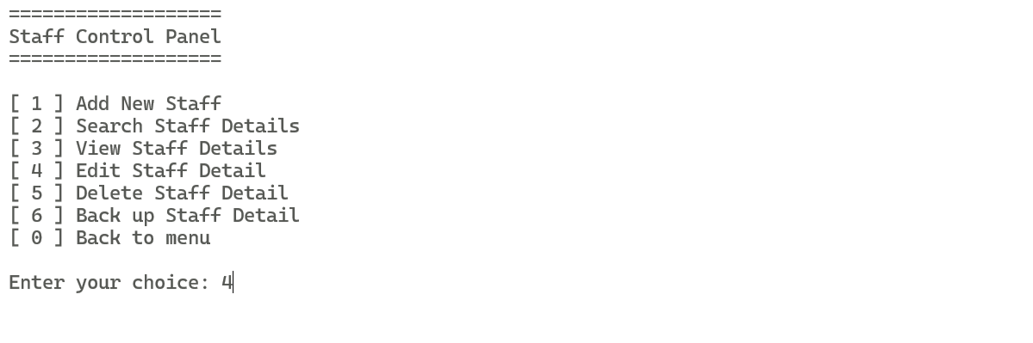

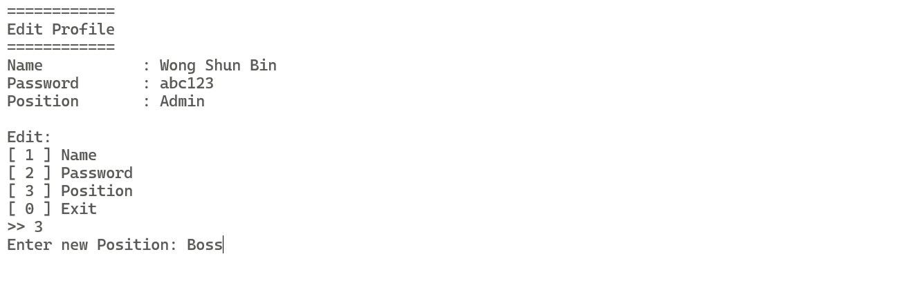

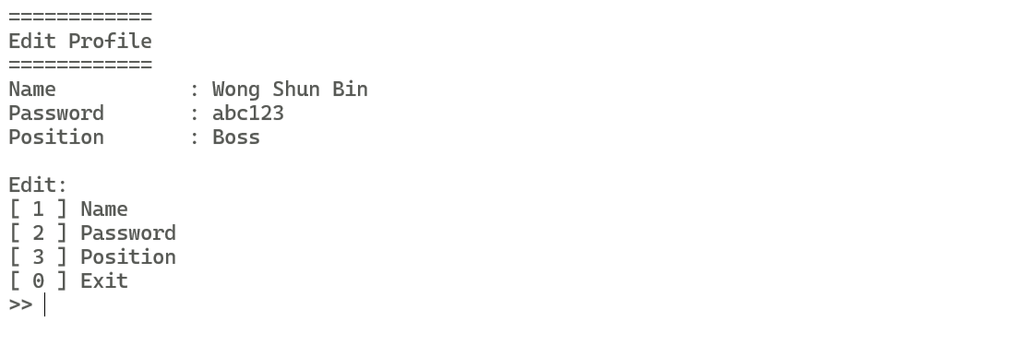

###### 

###### Deleting a Record: The user selects “Delete Staff” to remove a staff from the system.

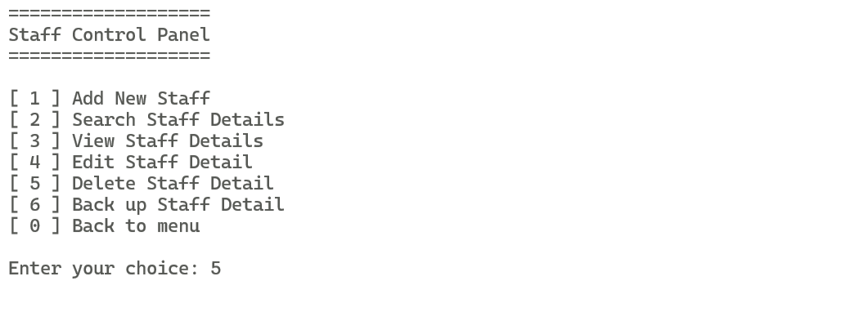

###### 

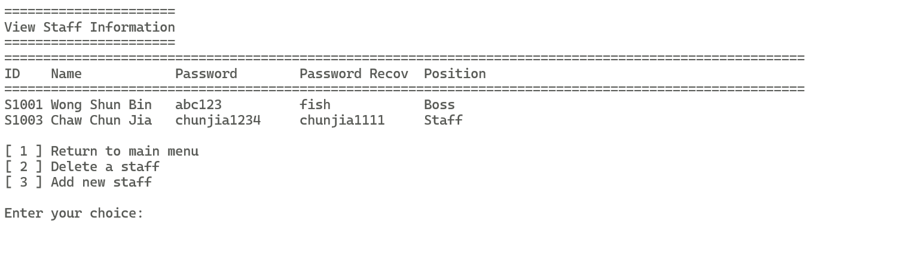

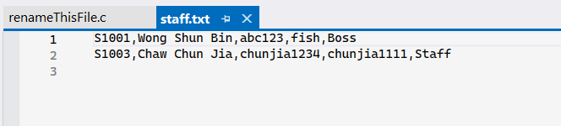

###### 

###### Search Staff: Allows the staff to search staff.

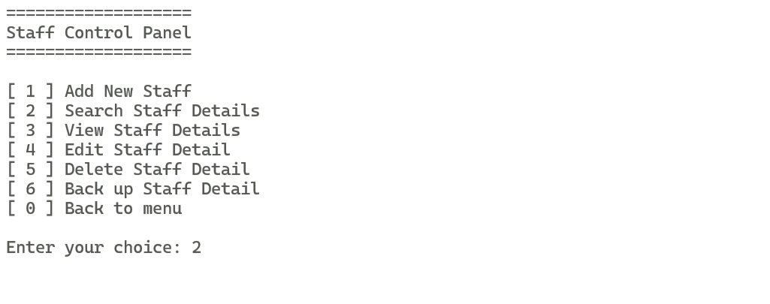

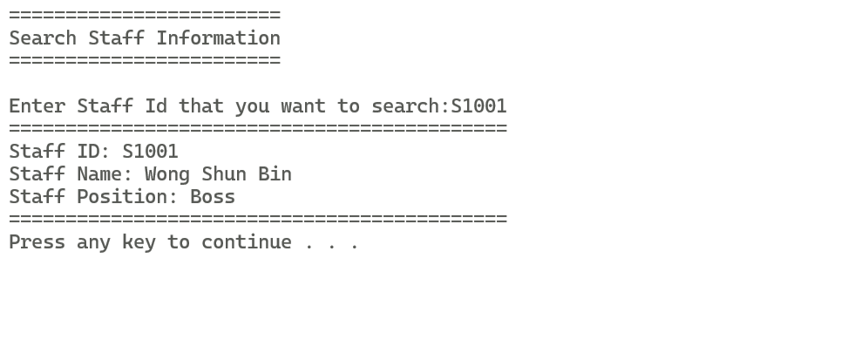

###### 

###### Backup Staff Details: Backup the file of staff to another file.

###### 

###### 

###### 

#### 4.2 Member Management by Ooi Jun Kang

##### 4.2.1 Description

The Member Information Module serves as the cornerstone for managing all member-related activities within the train ticketing system. It provides functionalities to add, view, modify, search member information, update member details and password recovery, ensuring accurate and secure storage of member data. This module caters to both administrative needs and member interactions, facilitating smooth operations and personalized services.

##### 4.2.2 Outputs & File Contents

###### Module's Main Page:

**Staff Side**

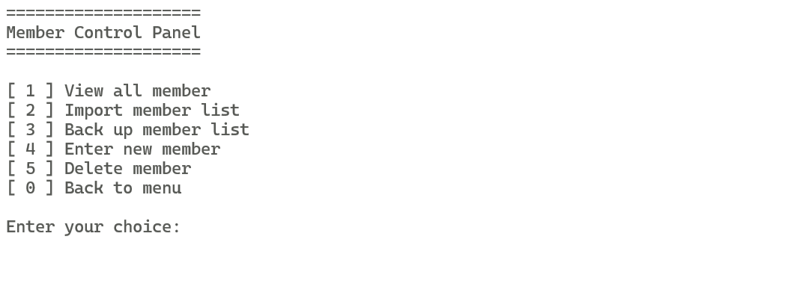

**User Side**

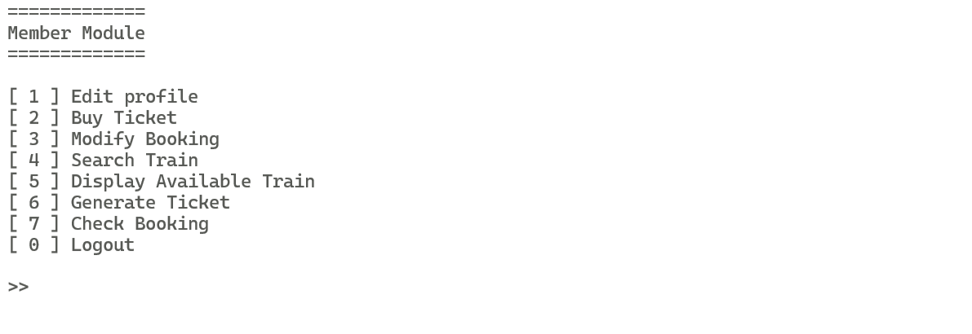

###### File's Existing Data: The user selects "Display Member" to view existing member records.

**Staff Side**

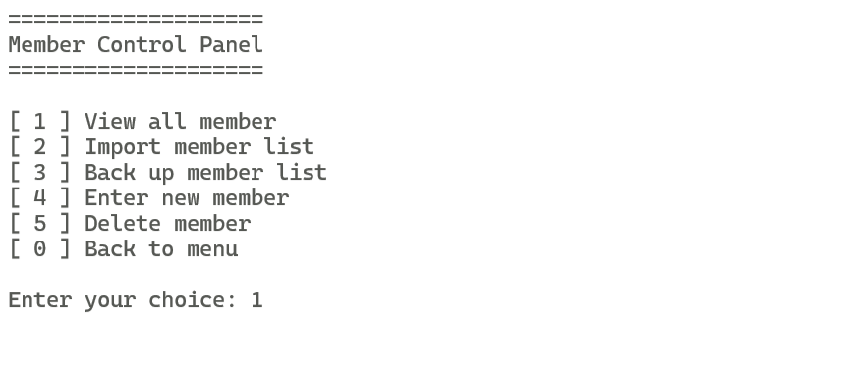

###### 

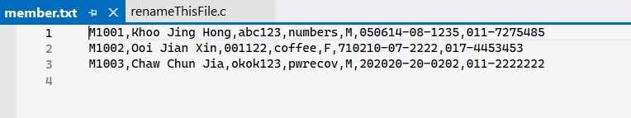

###### 

###### Adding a Record: The user selects "Add Member" and enters the details of the new member.

###### 

###### 

###### Modify a Record: The user select “Modify Member” and edit the field they wanted to edit.

###### 

###### 

###### 

###### Deleting a Record: The user selects “Delete Member” to remove a member from the system.

###### 

###### 

###### 

###### 

###### Display File's Updated Data: After confirmation, the system updates the file with the new member record.

###### 

###### 

###### Password Recovery: Recover password of the member.

###### 

###### 

###### 

#### 4.3 Train Scheduling by Chaw Chun Jia

##### 4.3.1 Description

The Train Scheduling Module is pivotal in orchestrating the movement of trains within the train ticketing system. It provides comprehensive functionalities to manage train schedules, including departure and arrival times, destinations, ticket prices, and seat availability.It also allows the user to modify train information of existing trains, display every created train, delete train and view train report. This module ensures efficient utilization of resources and seamless coordination of train services, enhancing the overall travel experience for passengers.

##### 4.3.2 Outputs & File Contents

###### Module's Main Page:

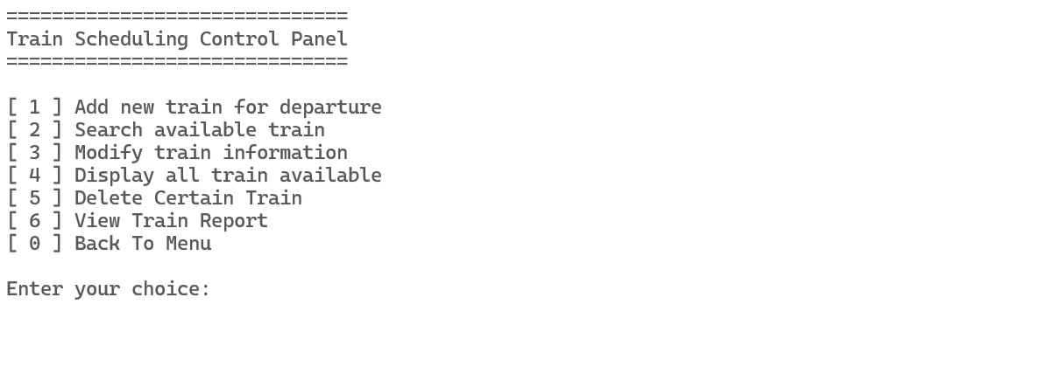

###### File's Existing Data: The user selects "Display Train" to view existing train records.

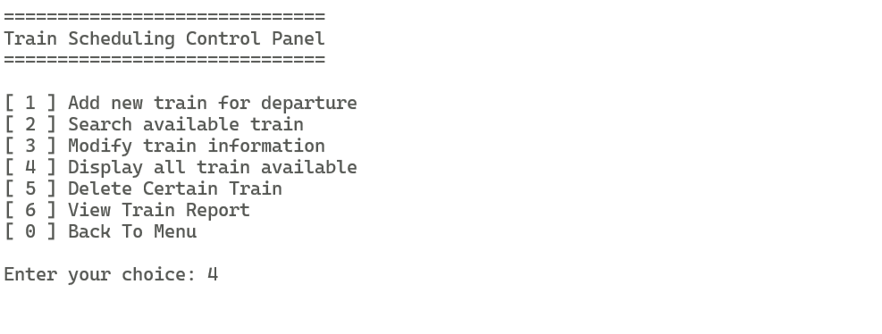

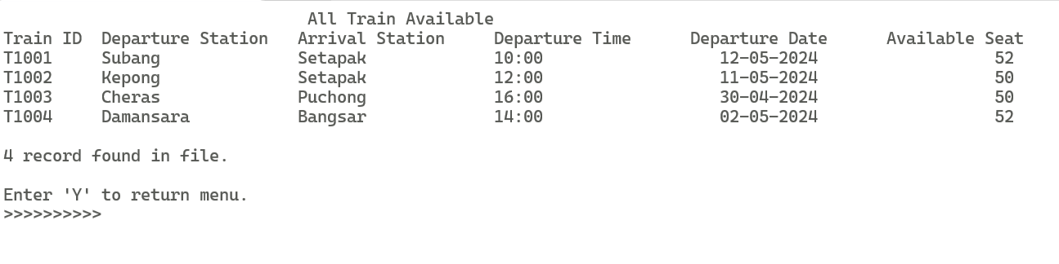

###### 

###### Adding a Record: The user selects "Add Train" and enters the details of the new train.

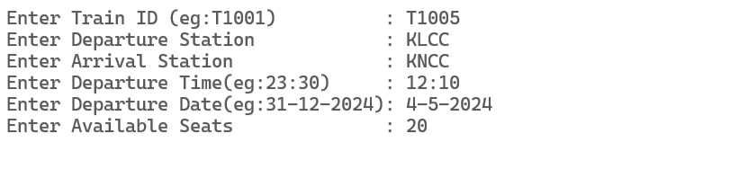

###### 

###### 

###### 

###### Modify a Record: The user select “Modify Train” and edit the field they wanted to edit.

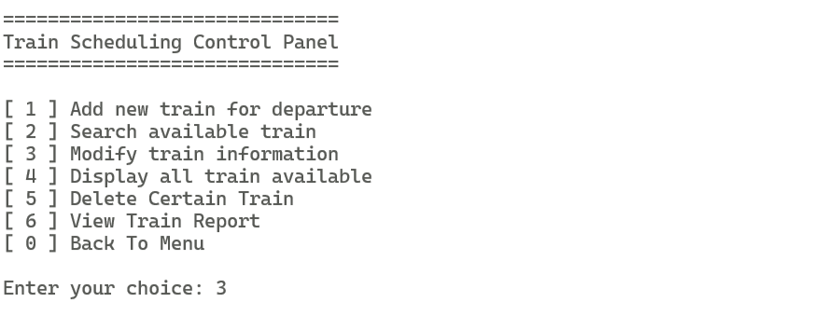

###### 

###### 

###### Deleting a Record: The user selects “Delete Train” to remove a train from the system.

###### 

###### 

###### Display File's Updated Data: After confirmation, the system updates the file with the new train record.

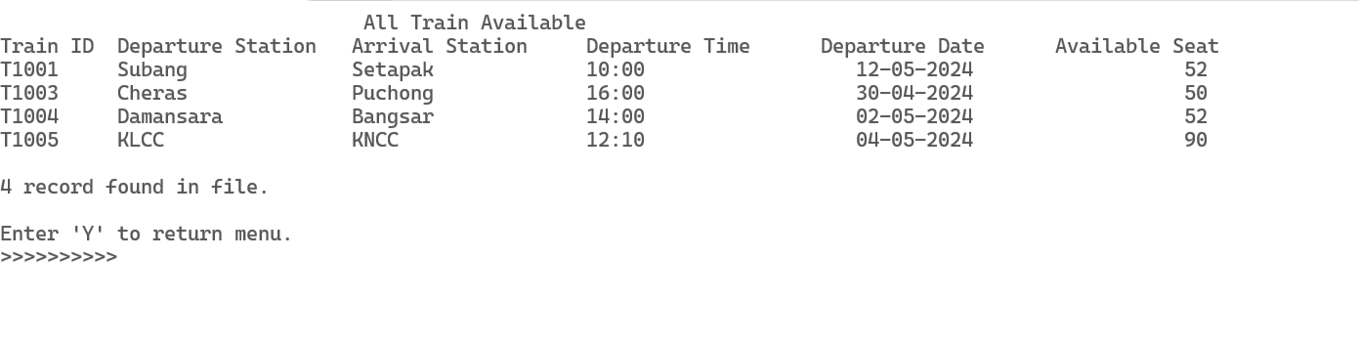

###### 

###### Backup Train Scheduled: Backup the current Train Information into another backup file to prevent lost of data.

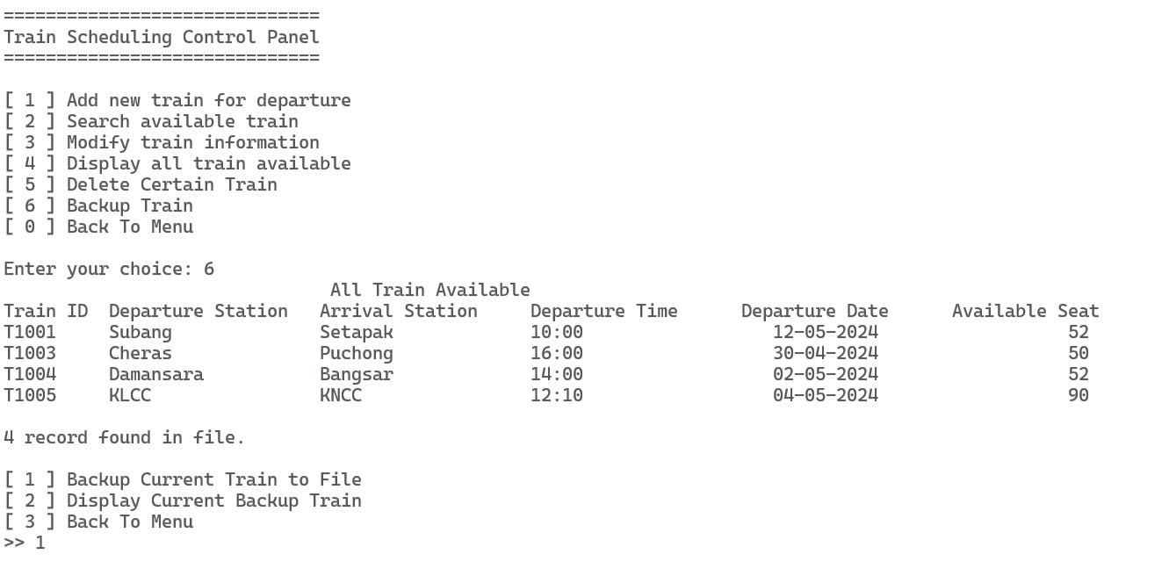

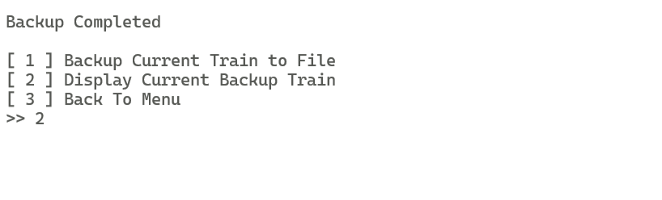

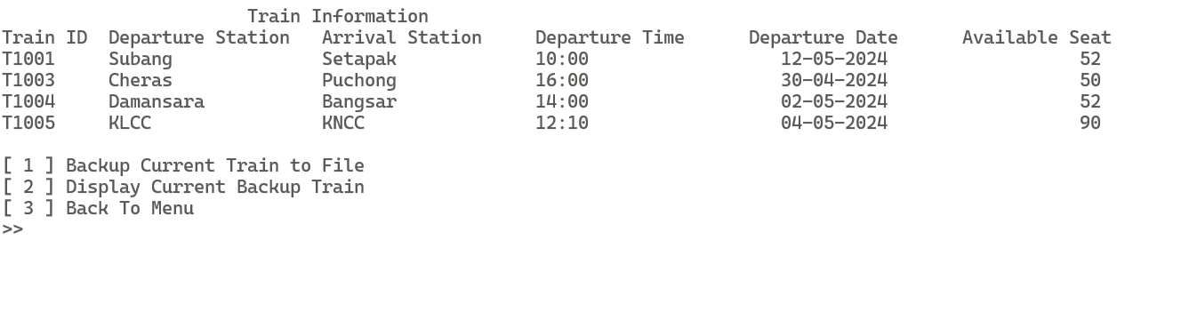

###### 

###### 

#### 4.4 Ticket Booking by Goh Chun Wen

##### 4.4.1 Description

The Ticket Booking Module serves as the primary interface for passengers to reserve and purchase train tickets within the train ticketing system. It provides a user-friendly experience, allowing passengers to buy ticket, modify booking, browse available train schedules,display all available train, generating ticket, and check their booking. This module streamlines the ticket booking process, ensuring convenience and efficiency for passengers while facilitating revenue generation for the railway company.

##### 4.4.2 Outputs & File Contents

###### Module's Main Page:

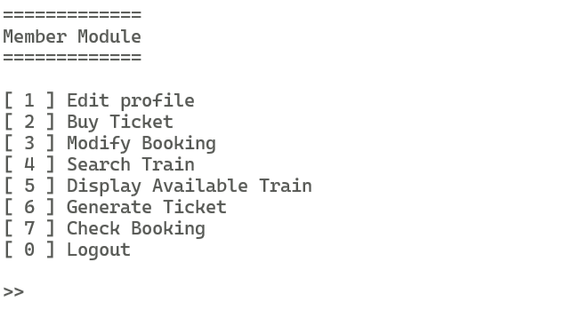

###### File's Existing Data: The user selects "Display Available Train" to view available train.

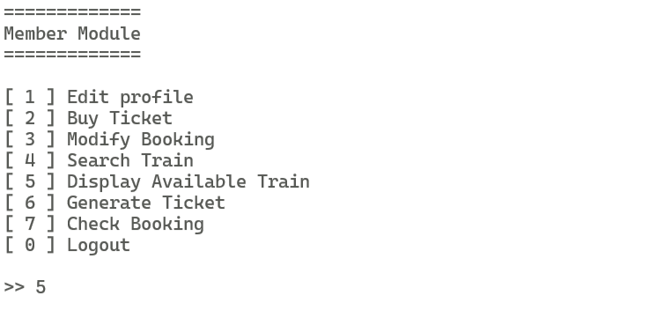

###### 

###### 

###### Adding a Record: The user selects "Buy Ticket" to book a train ticket.

###### 

###### 

###### 

###### 

###### Checking a Booking: The user select “Check Booking” and check the booking they’ve made.

###### 

###### 

###### 

###### Cancelling a booking: The user selects “Modify Booking” to modify a booking they’ve made.

###### 

###### 

###### Display File's Updated Data: After confirmation, the system updates the file with the new Booking record.

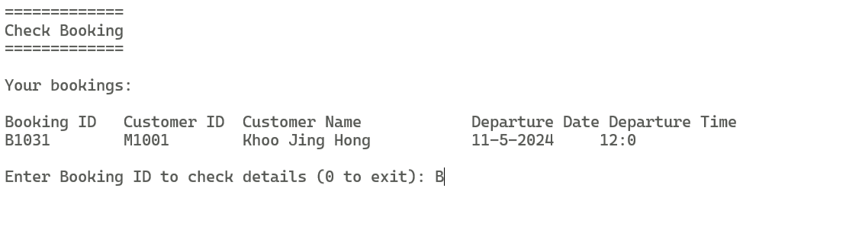

###### **Search Train availability:** Search for train with departure and arrival station

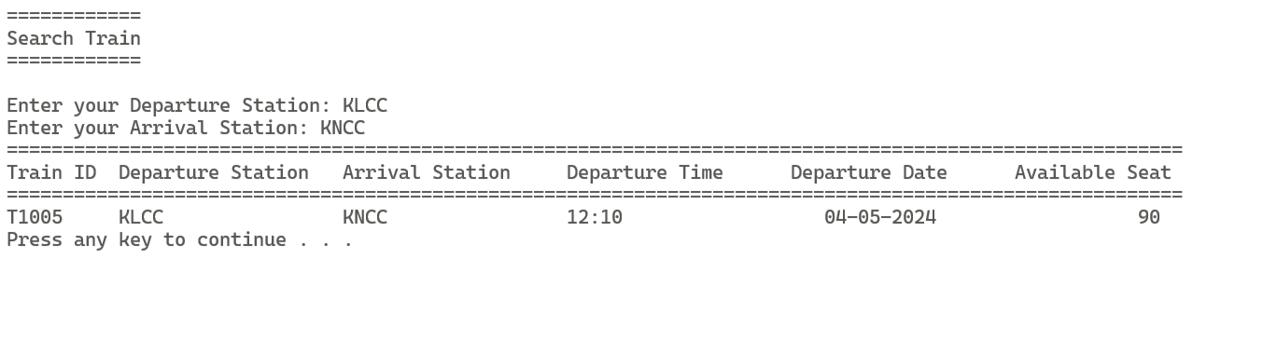

### References

1. *C library function - fseek()*. (n.d.). Tutorialspoint. Retrieved May 5, 2024, from https://www.tutorialspoint.com/c_standard_library/c_function_fseek.htm
2. *C library function - ftell()*. (n.d.). Tutorialspoint. Retrieved May 5, 2024, from https://www.tutorialspoint.com/c_standard_library/c_function_ftell.htm
3. *C library function - rewind()*. (n.d.). Tutorialspoint. Retrieved May 5, 2024, from https://www.tutorialspoint.com/c_standard_library/c_function_rewind.htm
4. *masking password input in windows terminal in C*. (2021, June 27). Stack Overflow. Retrieved May 5, 2024, from https://stackoverflow.com/questions/68151171/masking-password-input-in-windows-terminal-in-c